2.1 Reflex vs reflex

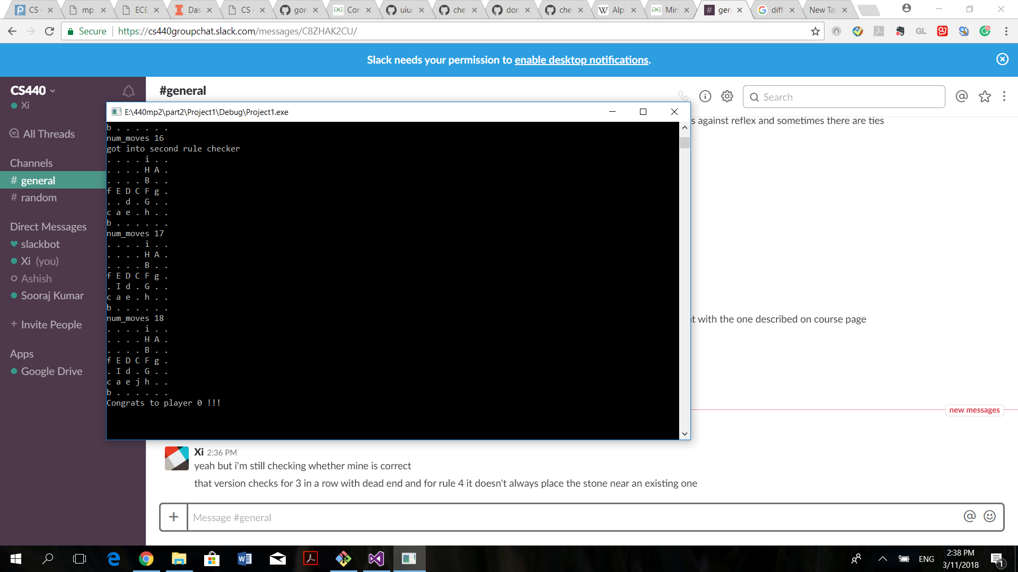

2.2. Minimax agent and Alpha-beta

Minimax/ Alpha beta result against reflex agent:

The evaluation function we used was good enough to permit our minimax and alpha beta agent to win against reflex agent when starting from a blank board. However, ties had appeared 2 times in 49 games when we assigned specific location for reflex agent to start. We assume it had resulted from that the principle of our evaluation function is to avoid lose rather than exploring winning patterns, we assigned more penalty for enemies near wins and award less value for agent’s near wins. Therefore, sometimes the agent doesn’t recognize and respond to near win patterns accurately.

The result for the 4 matches between minimax/ alpha-beta and reflex agent are shown below. Minimax agent and alpha-beta agent produce the exact same result.

Reflex vs alpha-beta

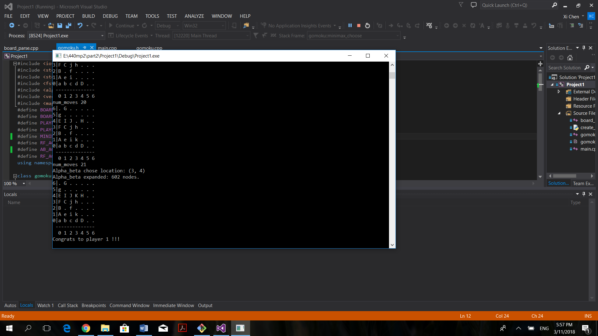

Reflex vs minimax

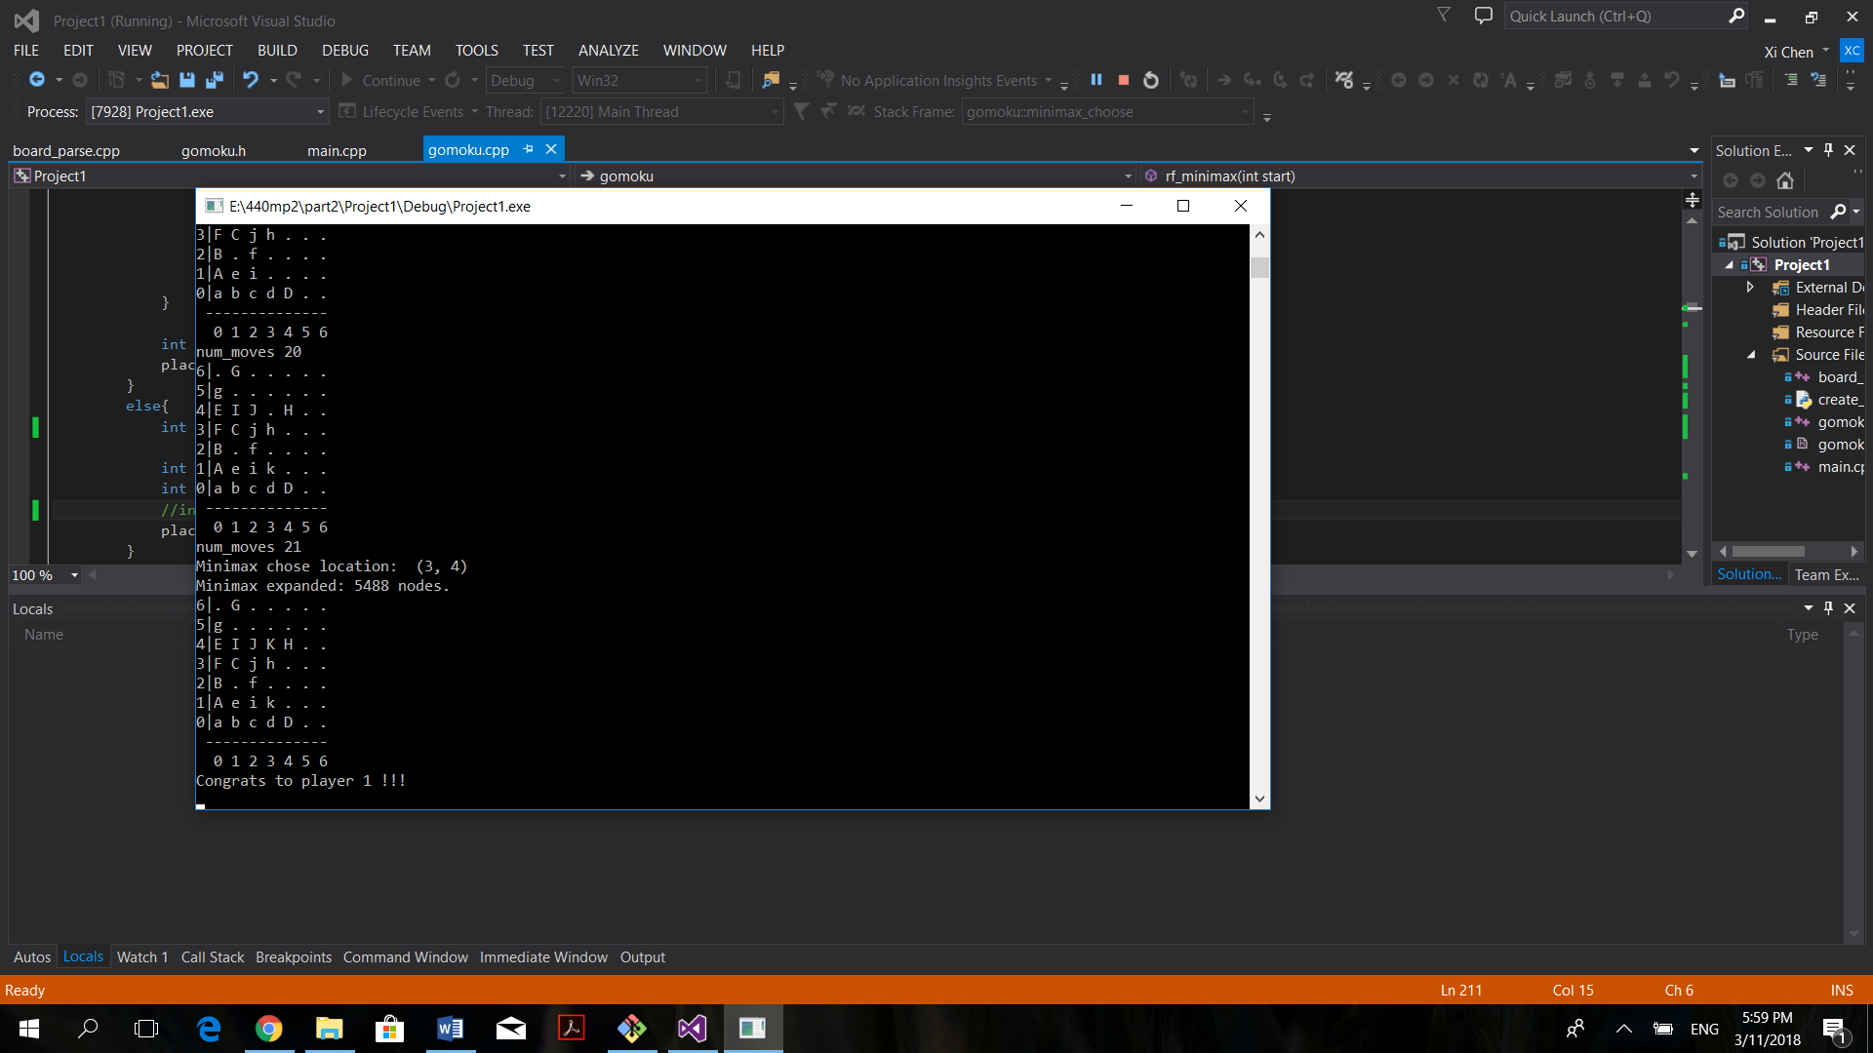

Alpha-beta vs reflex

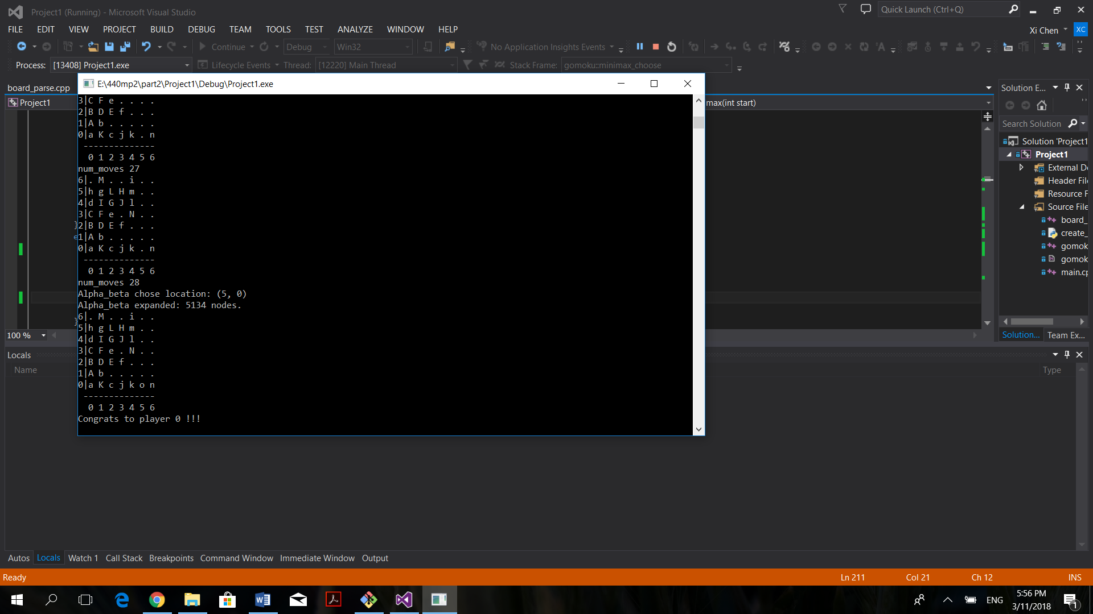

Minimax vs reflex

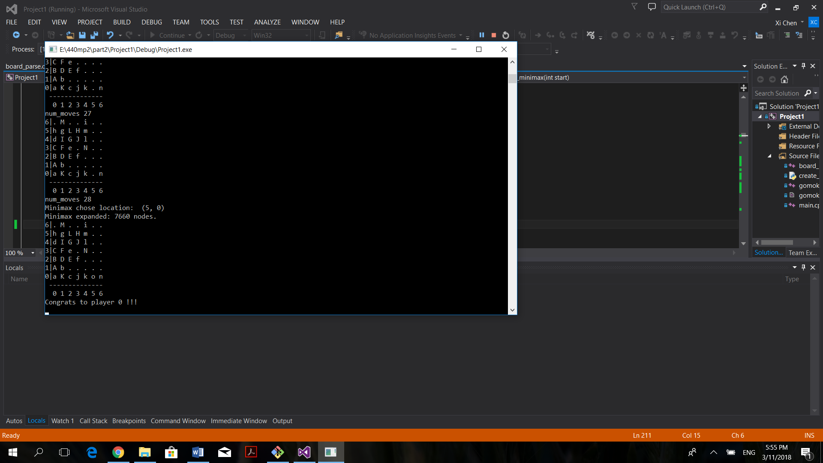

For the match-up between minimax and alpha-beta, our agents generate the same result regardless of which side to start first. The match up results are shown below.

Alpha-beta vs minimax

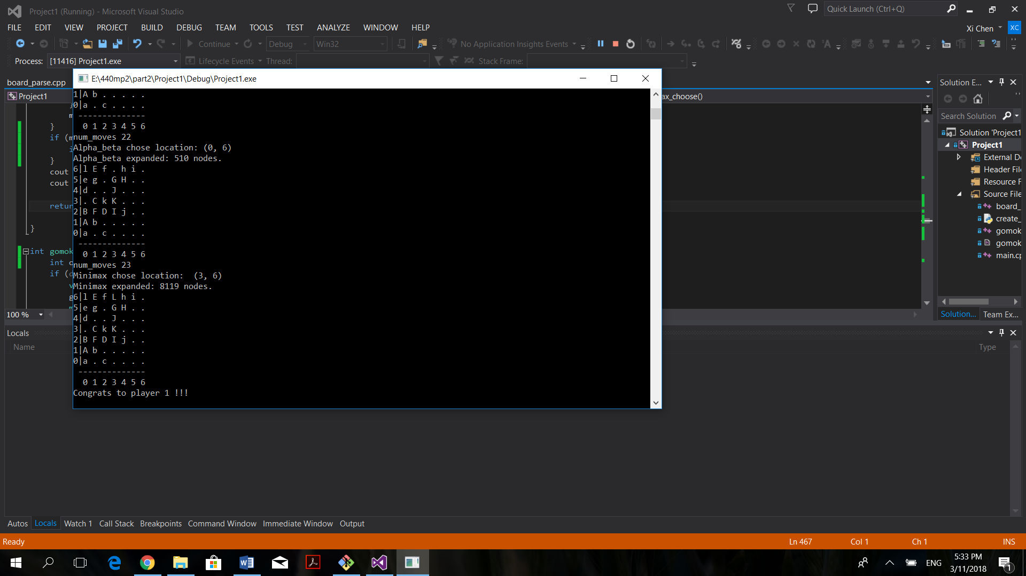

Minimax vs alpha-beta

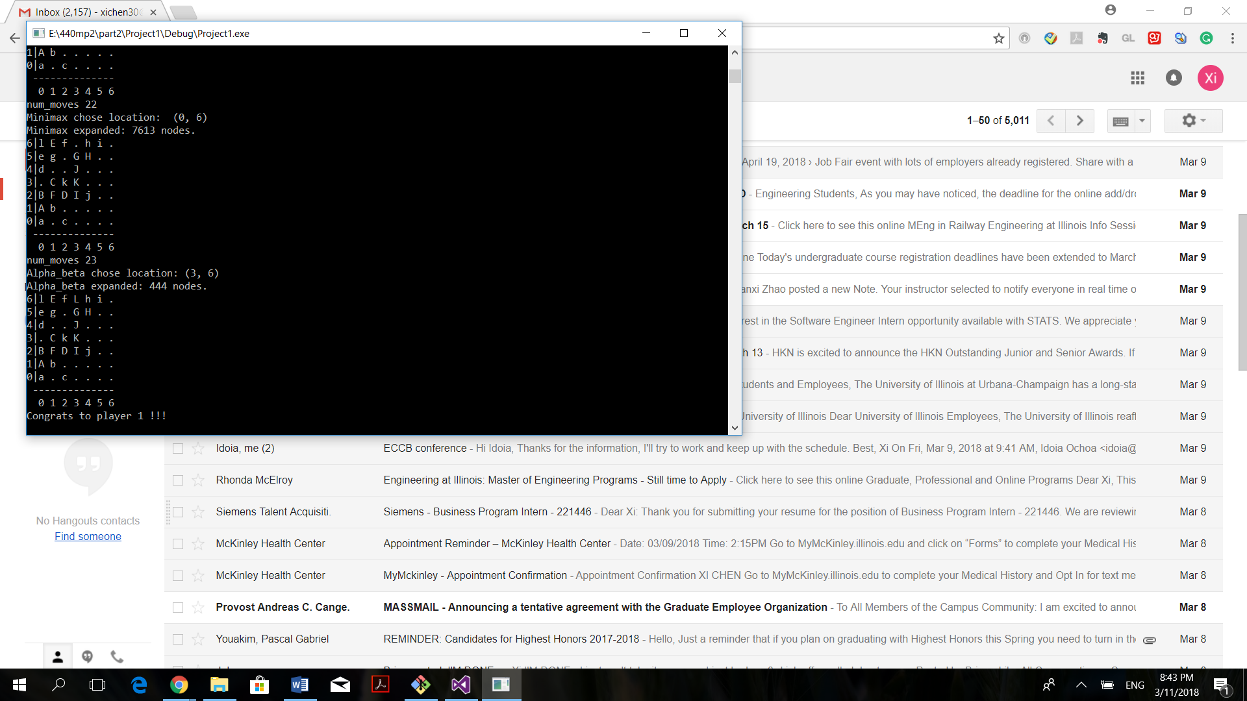

Since Alpha-beta is essentially pruned minimax search, we found out that it expands significantly less nodes than our minimax agent for each step. The comparison between nodes expanded are listed in the following chart.

2.4.1 User interface

We implemented a simple text-based user interface that allows human to play gomoku game against the computer. The interaction is based on console input and outputs, the board was printed out to the console at each step and it asks the user for coordinate of the next move. It is able to identify invalid inputs and invalid moves.

User has the option to play against all three agents (reflex, minimax, alpha-beta), and can choose which side to start first. At the end of each game, the program announces winner and asks user to start a new game.

